|  |  |
| --- | --- |
| PITINFOTECH  ESTIMATE/ 06/05/2025 | C-157, Mani Street, Thirunagar, Madurai, Tamil Nadu - 625006  Contact : +91 9043371538  Email : [ananthakumar7@gmail.com](mailto:ananthakumar7@gmail.com) |

# Introduction



This document describes our understanding of the server setup from the discussion with you and given time and cost estimation of each module. I've enclosed this **Online Permit Server** setup quotation based on **Shree Cements Online Permit System** requirements.

|  |  |
| --- | --- |
| **Shree Cements** | **ESTIMATED COST** |
| Rajasthan | Rs.1,70,000/- |

# Scope of this work



1. Create a new AWS server account and launch the desktop and mobile app.
2. Setup the app in Play Store and get approval from Google.
3. Create an instance for dev and prod for desktop and mobile app.
4. Server configuration setup is based on to the mail discussion.
5. According to the AWS T&C, they will charge the amount based on to the usage on every month. In case, if it’s usage come high, we’ll take care the responsibility.
6. **All below mentioned costs are fixed. No negotiable**
7. When purchasing or renewing an AWS account, final cost will be in USD. If you are paying in INR, the local currency will fluctuate based on the USD to INR exchange rate at the time of billing

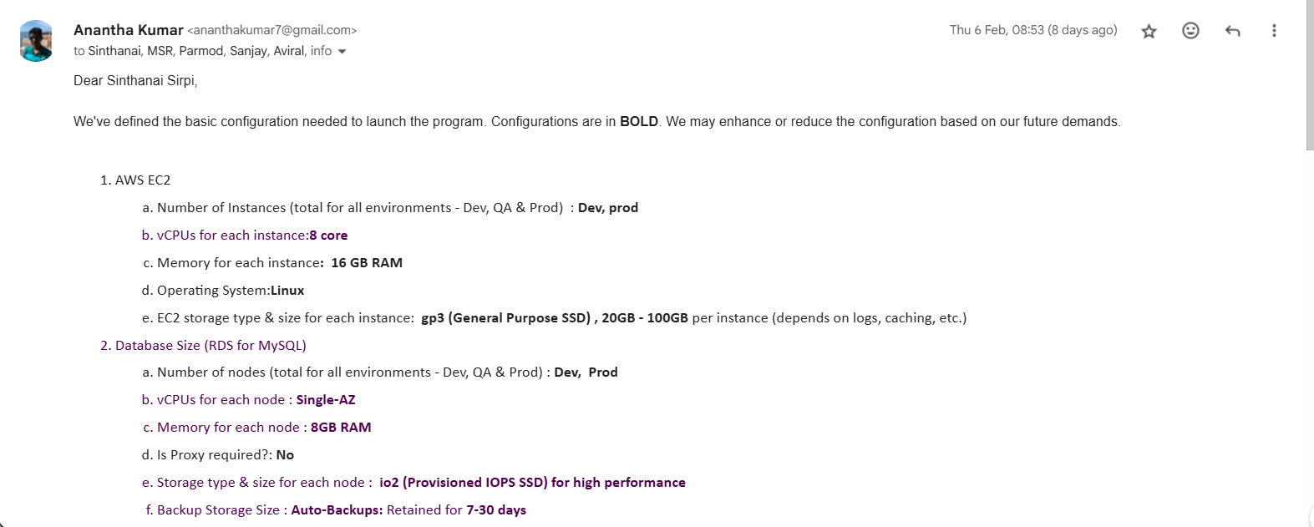

# Cost Estimation



**Cost Per Year**

|  |  |  |
| --- | --- | --- |
| Modules | Estimated Time (days) | Estimated Cost (Rs) |
| Purchase new AWS Account | 3 | 1,15,000/- |
| Server Support | - | 30,000/- |
|  |  | **1,45,000/-** |

**One Time Payment**

|  |  |  |
| --- | --- | --- |
| Modules | Estimated Time (days) | Estimated Cost (Rs) |
| Setup Server | 5 | 10,000/- |
| Mobile app setup in Google Play Store | 7 | 15,000/- |
|  |  | **25,000/-** |

Terms and conditions



1. This quote is valid for 15 days from the date of Issue.
2. This quote is for UK English site
3. Advance payment of **25%** is needed to start the work.
4. **50%** of amounts have to be given when application is uploaded in **PITINFOTECH** server for review.
5. Later **25%** will have to be paid after completion of site after review/handover to SCL.
6. Clients have to review within 14 days and inform any changes needed.
7. Bank details will be given in a separate attachment if confirmed.
8. If payment have been done client have to inform with receipts or any to move.
9. In case of client like to stop the work, **PITINFOTECH** need to get the payments as

per the schedule till that day and can bill according to the loss caused by this work if any.

Sincerely, Anantha Kumar RJ